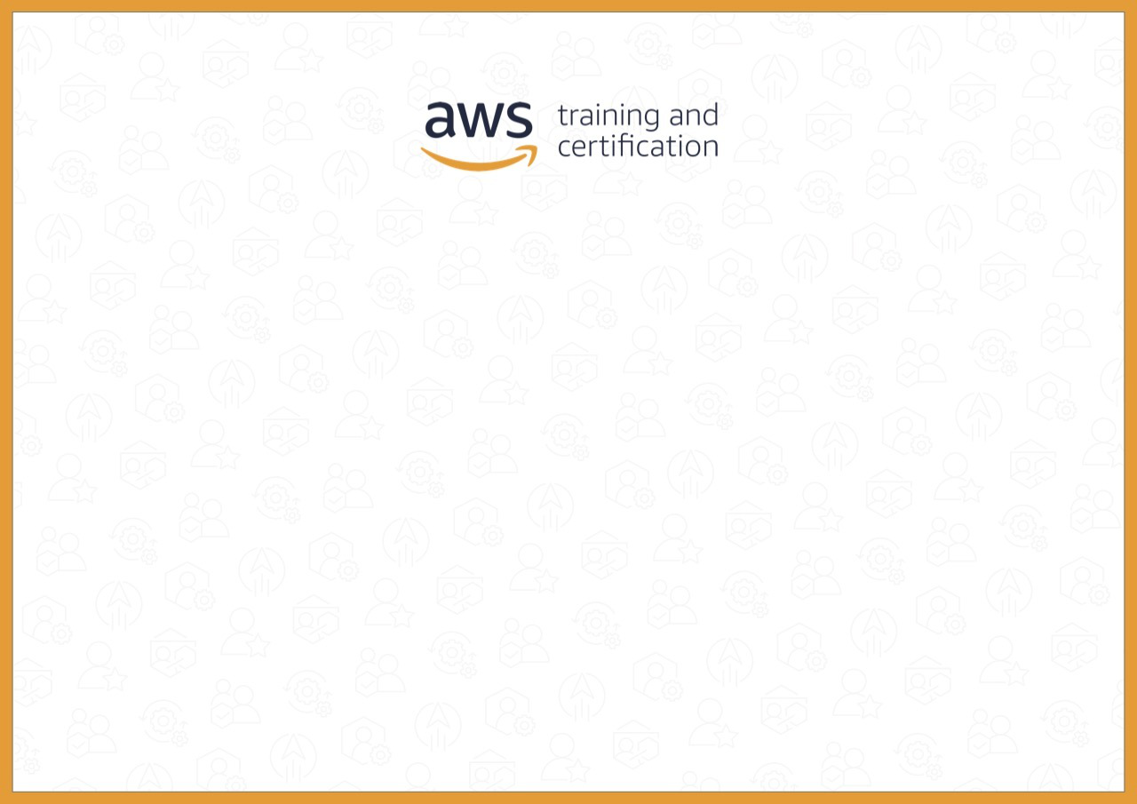

**Certificate of Completion**

**Anusha Thakur**   
successfully completed   
**AWS Skill Builder Learner Guide**   
on   
3/6/2024